David Ciorra

Gabriel Sabattino

The Baseball Pitch

The World Series is one of the most famous and viewed sporting invents in the world, since the 1800 its been America's beloved national pastime with the game having such a simple objective; score more runs than your opponent. The idea is to hit the ball thrown at you as far as you can before running around 4 bases to complete a run. Yet, despite the games simplicity there are over a dozen different pitches and because of this our project will explore and compare two very diverse pitches; the fastball and curve ball. The question at hand is quite straight forward, how does the effect of spin (which differs depending on which pitch is thrown) effect the trajectory of the baseball while in the air. The second question would then undoubtedly be which of these two pitches are more formidable for the batter to hit.

What we should expect is the following from each type of pitch

Topspin Pitch: Produces a downward swerve of a moving ball, a greater force than gravity would produce

Backspin Pitch: Upward swerve of the ball that makes the trajectory of it further than that of the topspin pitch

We will be generating graphs from both of these types of pitches and will be comparing them to actual Major League Baseball data.

**The model and computational methods**

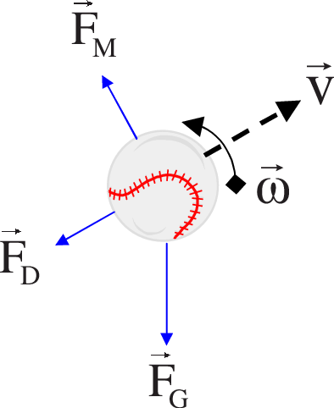

In the diagram above, Fg is the force of gravity defined as:

Fg= *(m × g)*

Where:

*M*=mass of ball

*g* =gravitational acceleration (9.8m/s2)

The opposing force to Fg is Fm (Magnus force). The Magnus Force is the lift on a ball or spinning object moving through a fluid.  Fm is defined as:

*Fm = S (w × v)*

Where:

*Fm* =the Magnus force vector

*w*= angular velocity vector of the object(rad/s)

*v=*Velocity of the fluid (or velocity of object, depends on perspective)  
  
*S=* air resistance coefficient across the surface of the object (Spin)

Perpendicular to the Magnus Force is Fd (Drag Force). Fd can be seen as air friction or air resistance. Causes the slowing down of an object. Fd can be defined as:

Fd = 0.5 x C x ρ x A x V2 

Where:

A = Area of ball.  
C = Drag coefficient (0.40).   
V = Velocity, m/s.  
ρ = Density of fluid (liquid or gas), kg/m3.

Opposite to Fd we have V(velocity) which is a measure of how fast something moves in a particular direction. V is defined as:

V=Vo + a x 

Vo= Initial Velocity

a=acceleration

= The time interval between the original and final situations.

Lastly, there’s angular velocity which is the rate of change of angular position of a rotating body. This is defined as:

W=V/R

Where:

W= angular velocity

V=linear Velocity

R= radius of ball

**Results**

After plotting both pitch trajectories; back spin pitch and top spin pitch, we obtain the following. It can clearly be seen that the back-spin pitch, that is mostly used in fastballs to avoid the downward curve of the ball, has more of a linear trajectory as compared to the top spin pitch. This is so since the top spin pitch, as seen from our graph below, has more of a curved trajectory. The top spin pitch is mostly used in curveballs since it makes the ball dip downwards which makes it more challenging for the batter. Our graphs seem to generate a lot of lift in our pitches which is not a real-life situation. The reason why this was down was to clearly point out the trajectory of each type of pitch.

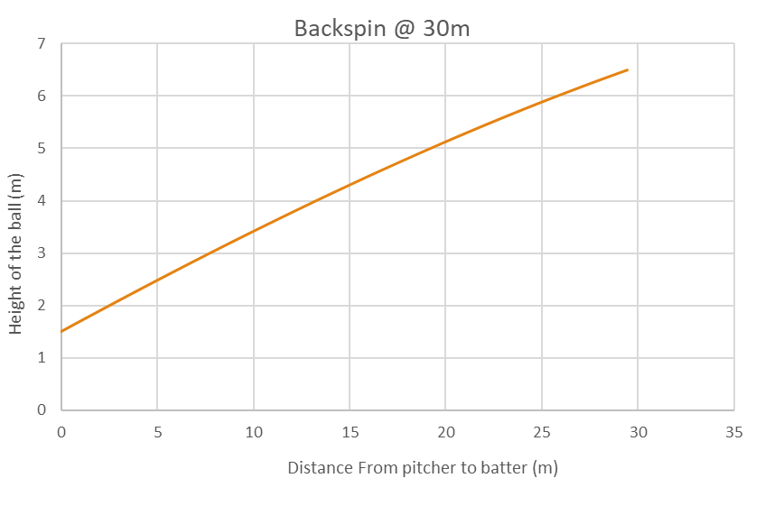

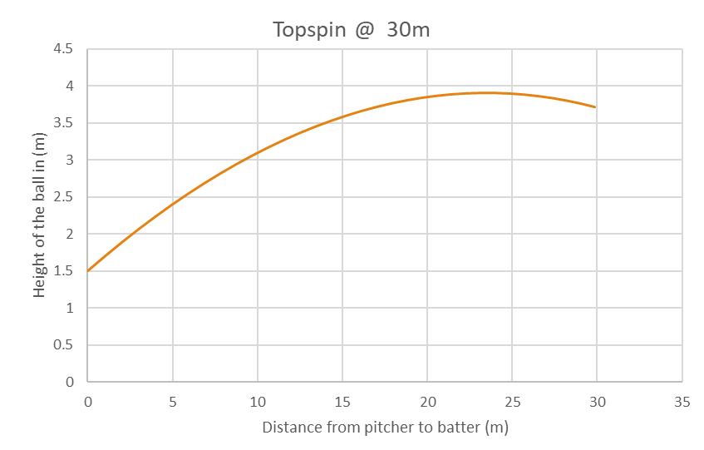

The graph below demonstrates how the fastball pitch looks like compared to the vertical and horizontal distances to the home plate. This graph also puts the curveball into perspective. These pitches were thrown by a professional MLB player named Ted Lilly.

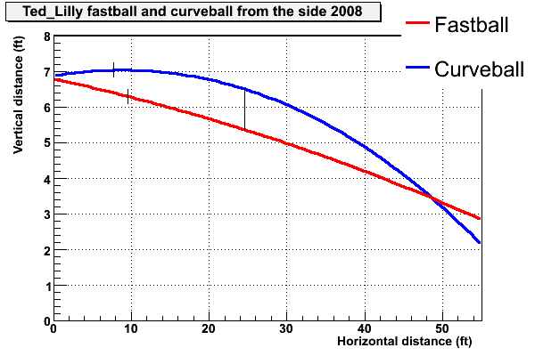

It can clearly be seen how the blue curve resembles the curve we obtained from our graph depicting top spin pitch trajectory. This blue curve is the trajectory of a ball thrown with topspin (a curveball). It can also be seen how the red, almost linear line, resembles our back spin pitch curve. The red line depicts a fastball which utilizes topspin. By seeing how we got near identical results, we can compare our data.

Link: https://tht.fangraphs.com/pitch-sequence-high-fastball-then-curveball/

**Human Reaction**

A fastball (backspin pitch), from a professional pitcher (90 miles per hour), will only take 400 thousandths of a second to reach home plate. When the pitcher throws the baseball towards the plate, the batter must decide to swing when the ball is mid-point towards the plate. This is approximately about 25-30 feet from home plate. This is so since at that point, the ball will arrive 250 thousandths of a second later; this is the average human reaction time. The batter must not only decide where he should swing, but he must also decide whether he shouldn’t swing at all if the ball is not in the proper zone. Hitting the ball a little too high or a little too low will result either in a foul ball or a ground ball.



Even though curveballs are generally thrown slower than fastballs, they have their own qualities. Compared to a fastball, a curveball varies around 15-20 degrees more in vertical and horizontal movement. This makes it therefore harder to hit since when the ball is halfway towards home plate, the batter basically has to guess which way the ball will dip and curve. The longer trajectory of the curveball towards the home plate accounts for its variation of degrees.

**Discussion**

The results that we have obtained from our graphs show almost identical curves compared to an actual MLB pitcher’s graph. We do have different altitudes in which the pitch reaches however, the trajectories to get there are identical. We have examined our graphs and have concluded that throwing a fastball is the most effective pitch for the pitcher to throw since it is the most reliable and easiest to control. However, the curveball is perfect for confusing the batter. The curveball is harder to throw but has a great outcome when done properly. The reaction time of a human is challenged more when he/she tries to hit a curveball which makes it harder to hit.

References

https://tht.fangraphs.com/pitch-sequence-high-fastball-then-curveball/

<https://backyardbrains.com/experiments/reactiontime>

Book by Nicholas Giordano: College Physics: Reasoning and Relationships